## Arrows

Frequently, you will need to draw attention to items on the plan, but will not want to use a callout box. RapidPlan provides two arrow tools for this purpose:

* The Arrow Tool
* The Arrow Text Tool

As the names suggest, the latter carries a text component at its base. The arrows can be curved or straight, as shown.

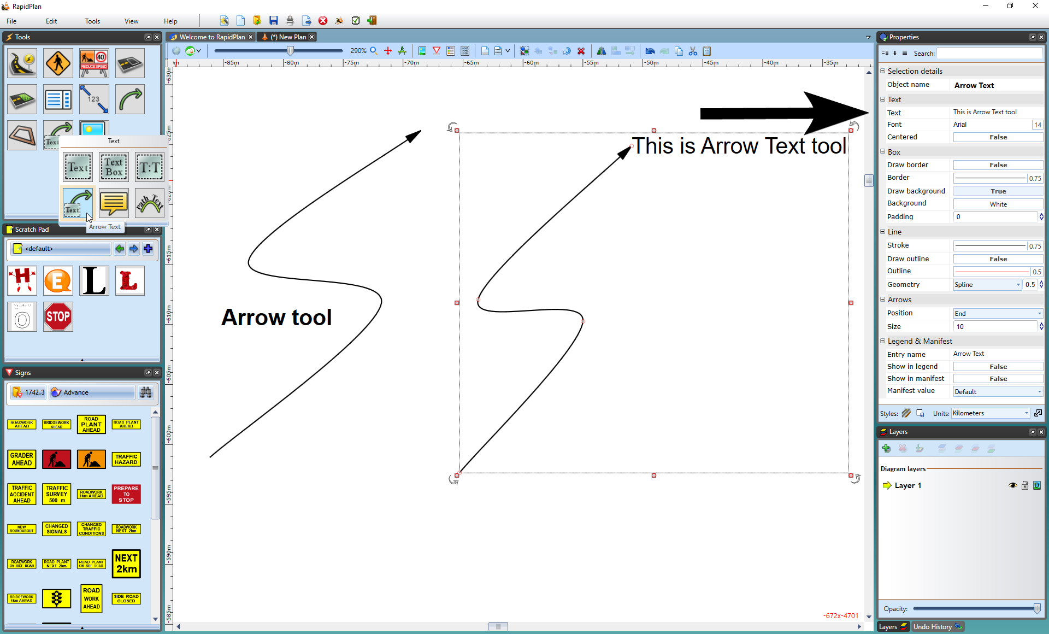

The_Arrow_tool_and_The_Arrow_Text_Tool

## Creating an Arrow

* Select the **Arrow** tool from the Lines tab in the Tools Palette.
* Click to place the head of the arrow.
* Click again for each subsequent turn point that you require.
* When you have placed your final point, right click.
* Right click to clear the cursor.